

Ref: 2645/Circular/05.10

1 May 2010

All Residents
No.9, 11,15 Ardmore Park, Singapore

Dear Residents,

SERVICING SCHEDULE FOR THE MONTH OF MAY 2010

Please be informed of the following servicing schedules for the lifts/fire protection system/pest control/recycling for the month of
MAY 2010.

S/No | Contractor | Services | Date | Time | Remarks
1 | B.S. Engineering Co Pte Ltd | Fire Protection | 17 May 2010 | 1300hrs to 1700hrs | Please do not be alarmed when the fire alarm is activated
2 | ABJ Pest Control Pte Ltd | Pest Control | 6, 13, 20 & 27  May 2010 | Between 0930hrs to 1200hrs | Please close (seal) your bin chute hopper and windows tightly during the fumigation
3 | In-house | Collection of Recycle Materials | Daily | From 0800hrs to 0930hrs | Please place recyclable materials besides the service lift area for collection.
4. | Anchor Cleaning Agency Pte Ltd | Bin Chute Flushing | 1, 5, 8, 12, 15, 19, 22, 26 & 29 May 2010  (Every Wed & Sat) | From 1000hrs to 1200hrs | Please close your bin chute hopper during the flushing

Lift Maintenance Schedule
Blk No | Lift No | Date | Time | Remarks
Block 9 | Lobby Lift No 1  Lobby Lift No 2  Lobby Lift No 3  Lobby Lift No 4  Service Lobby Lift No 10 | 18 May 2010  18 May 2010  18 May 2010  18 May 2010  18 May 2010 | 0900hrs to 1030hrs  1030hrs to 1200hrs  1300hrs to 1430hrs  1430hrs to 1600hrs  1600hrs to 1730hrs | Kindly be reminded to bring along your rear door key during this period. Our security officer may fermax your unit for permission to test the operation of the lift to your floor.
Block 11 | Lobby Lift No 5  Lobby Lift No 6  Lobby Lift No 7  Lobby Lift No 8  Service Lobby Lift No 11 | 19 May 2010  19 May 2010  19 May 2010  19 May 2010  19 May 2010 | 0900hrs to 1030hrs  1030hrs to 1200hrs  1300hrs to 1430hrs  1430hrs to 1600hrs  1600hrs to 1730hrs | Kindly be reminded to bring along your rear door key during this period. . Our security officer may fermax your unit for permission to test the operation of the lift to your floor.
Block 13 | Club House P1 | 20 May 2010 | 1730hrs to 1900hrs
Block 15 | Lobby Lift No 9  Lobby Lift No 10  Lobby Lift No 11  Lobby Lift No 12  Service Lobby Lift No 12 | 20 May 2010  20 May 2010  20 May 2010  20 May 2010  20 May 2010 | 0900hrs to 1030hrs  1030hrs to 1200hrs  1300hrs to 1430hrs  1430hrs to 1600hrs  1600hrs to 1730hrs | Kindly be reminded to bring along your rear door key during this period. . Our security officer may fermax your unit for permission to test the operation of the lift to your floor.
Weekly high-level dusting and cleaning of the private lift cars schedule:
Day of Cleaning | Time | Block /Lift Nos. | Remarks
Monday  Tuesday  Wednesday | 10.00 am to 11.00 am  11.00 am to 12.00 pm  10.00 am to 11.00 am  11.00 am to 12.00 pm  10.00 am to 11.00 am  11.00 am to 12.00 pm | Blk 9/ Lift 1 & 2  Blk 9/ Lift 3 & 4  Blk 11/ Lift 5 & 6  Blk 11/ Lift 7 & 8  Blk 15/ Lift 9 & 10  Blk 15/ Lift 11 & 12 | Please do not be alarmed if you find a cleaner in the private lift during these times.

Please note that the servicing of each lift will take one and a half hours to complete, instead of an hour each this time round.

If you have any queries, please feel free to contact us at the management office telephone number 6733 0862. We apologise for any inconvenience caused.

Yours Faithfully,

Knight Frank Estate Management Pte Ltd
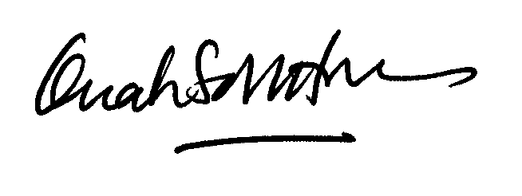

Ms Quah Soh Hoon
Ardmore Park General Manager
For and on behalf of The MCST Plan No. 2645

